Armen Sarkisian

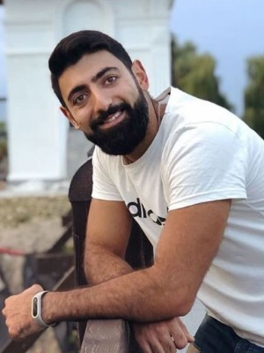

Date of Birth: 18.06.1994

Place of Birth: Dnipropetrovsk, Ukraine

Living place: Dnipro, Ukraine

e-mail: a.sarkisian94@gmail.com

phone: +38 (093) 426 19 07

Skype: armenchik724

**Target**

Get an Web or Mobile developer position.

**Programming skills**

C#, .Net

MySQL, Git

MVVM, MVC

HTML, CSS

**Education**

National Metallutgical Academy of Ukraine

Specialty: material science.

**Educational courses**

Javarush.ru Java, Android

123Software Mobile developer

**Language skills**

|  |  |
| --- | --- |
| Ukrainian | Native |
| Russian | Native |
| English | Pre-intermediate |
| Armenian | Pre-intermediate |
| German | Beginner |
| Turkish | Beginner |